
AUTUMN SCHOOL HOLIDAY PROGRAM

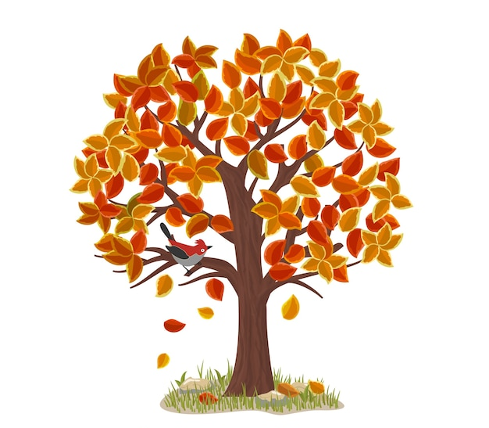

Forest Park Riding and Equitation School has been run by Grant and Heather Hughes for many years and they have promoted a nurturing family environment for all their clients. The overriding goal at Forest Park is to share their love of horses and horse riding with everyone wishing to be involved in equine pursuits no matter how young or old.

Our horses.
We have a large group of reliable and well trained horses available to suit all standards of riders.

Our Instructors.
We have a dedicated and experienced group of instructors at Forest Park who are passionate and experienced at instructing horse riding, as well as enjoy riding or competing their own horses. Some of our instructors have completed further study to enhance their skills, such as attaining qualifications through the Equestrian Federation of Australia N.C.A.S. Note that all instructors undergo regular in-house training including safety aspects of horsemanship, have first aid certificate and working with vulnerable people card.

Times: Daily 9am-4pm
Please ensure you bring your child to the office each day on arrival to sign in.
Staff will not be on duty to supervise children before 8:45am daily. We expect parents to pick up their children promptly at 4:00pm. We also require those children with their own horses to have adult supervision outside these times.




www.forestparkridingschool.com.au
ABN 14065848875
Autumn School Holiday Programs
Phone: (02) 62874888 Fax: (02) 62875888
Website: www.forestparkridingschool.com.au
E-mail: hughes81@bigpond.net.au
912 Cotter Rd Stromlo ACT 2611
PO Box 3548, Weston ACT 2611

Monday 14/4/25 – Thursday 17/4/25 (4 days)
Tuesday 22/4/25 – Thursday 24/4/25 (3 days)
Friday 25/4/25 (1 day beginners)

Member of Australian Horse Riding Centres NSW
Follow us for updates!
One - four day programs
April 2025
Daily 9am—4pm

Eligible: 7—16 YEARS

Cost:. 4 day program $560.00. 3 day program 420.00.
1 day program $150.00

Children bringing their own horses will not be charged for the week’s stabling; however a $30.00 sawdust/cleaning charge will apply and is due one week prior to the program.

Deposit: $100.00 (NON REFUNDABLE)
The balance of payment is due two weeks prior to the first day of program. Failure to pay outstanding balance will then result in place being given to the first person on the waiting list.

Please note: Payment method is by cash, card, bank transfer or cheque. 1.5% surcharge applies to credit cards

Due to the popularity of our programs we will be allocating places strictly in order of receipt of your deposit. Please note that deposits will not be refundable.
No phone bookings can be taken.

Other information:
Photos. We may take photos of your child and his/her horse. We will ask you to sign a permission form if we wish to publish your child’s photo.

Cancellation/refund policy
No refunds will be given if a child is unable, or declines to attend all or part of the holiday program. A medical certificate will be required in the case of illness for consideration for a refund.

Daily routine:
The children a divided into 3 groups according to age and experience. There are no more than 8-10 children to a group. They are allocated their own horse for the week and learn about grooming, feeding and caring for their horse. The children are taught riding skills and are taken on supervised trail rides.
They are able to ride twice daily. Each group has one instructor and an assistant. Each morning of the program a safety talk is given by one of our instructors on the various safety aspects of working around horses.

Children will have the chance for a break for morning and afternoon teas, and also for lunch. Please ensure you have packed plenty of food and drinks (two large bottles of water) to last a full day, including morning and afternoon tea. We encourage regular drink breaks, especially in the hot weather. We also encourage nutrition and ask that parents ensure their children eat a good breakfast each morning before they attend our program.

What to wear and bring: Jodphurs or track pants, shirts with sleeves, lunch, morning and afternoon tea in a lunch box, drinks, warm clothing, sun hat, sunscreen, fly repellent, parker/raincoat, pen and paper, suitable shoes/riding boots. Your child’s belongings should be contained in a zip up bag such as a sports bag. Please label all belongings.

We are not responsible for the loss or damage of personal items.
We strongly recommend that children do not bring valuables such as mobile phones or other electronic devices.

Safety Equipment: Some approved riding helmets & boots are available, however it is strongly suggested that you supply your own. We recommend Horseland - Fyshwick .

WARNING—HORSE RIDING AND HANDLING CAN BE DANGEROUS ACTIVITIES

WARNING—HORSE RIDING AND HANDLING CAN BE DANGEROUS ACTIVITIES

